Rhombus
# Source: AI Source: Provided by: [Data Path: Persons Table -> ID Column: 1, Name_En Column: Motasem Essam] -> From: [ChatGPT] on [7/25/2026]
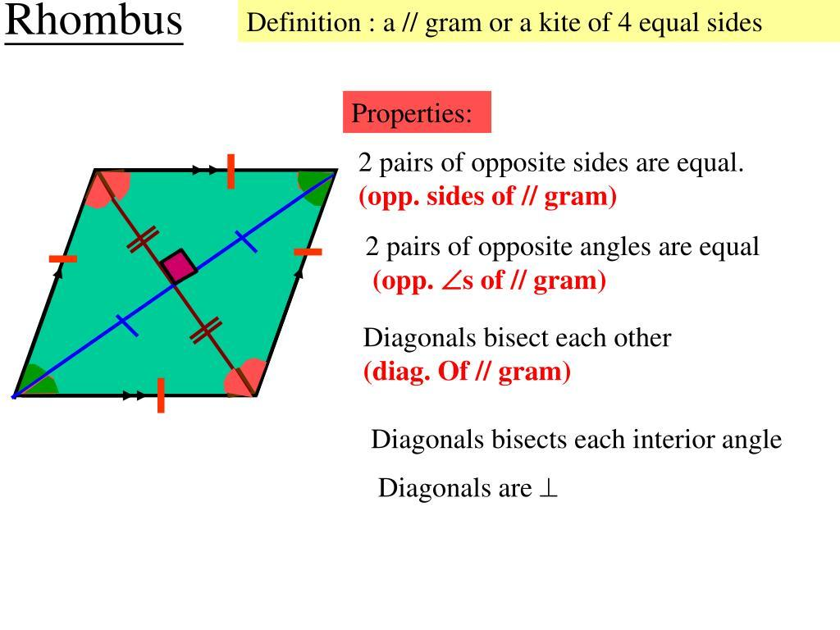
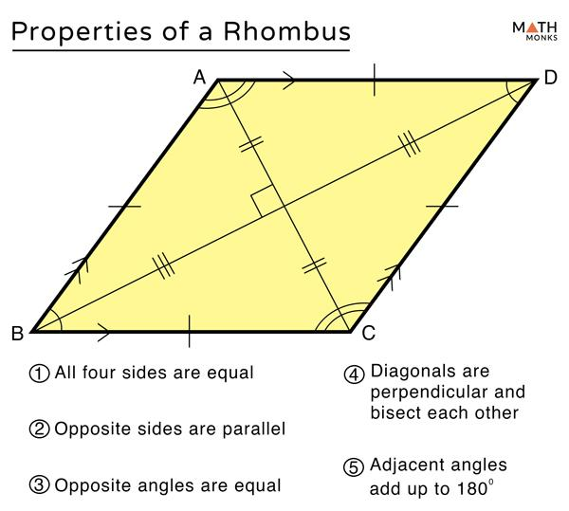
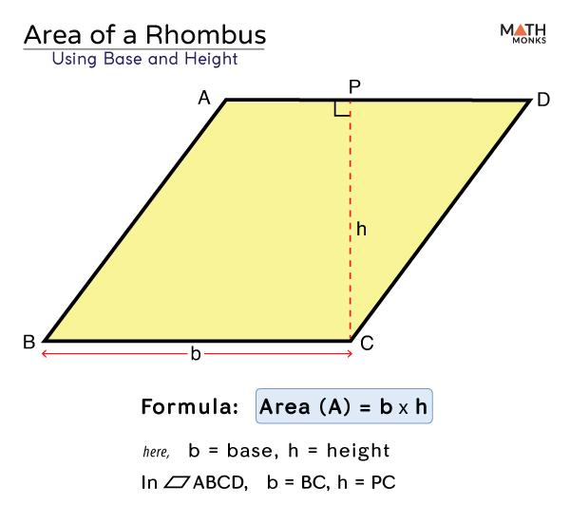
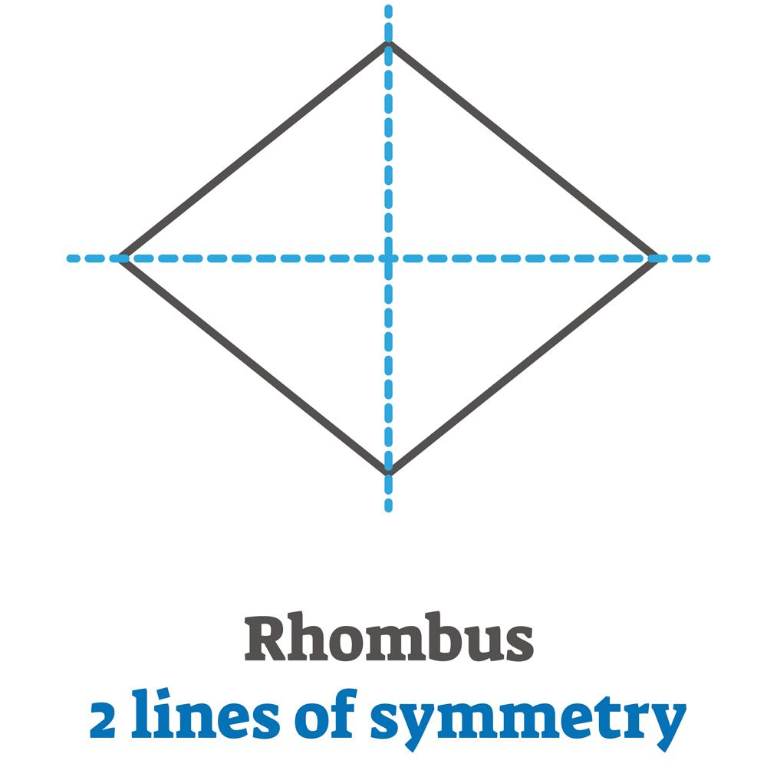
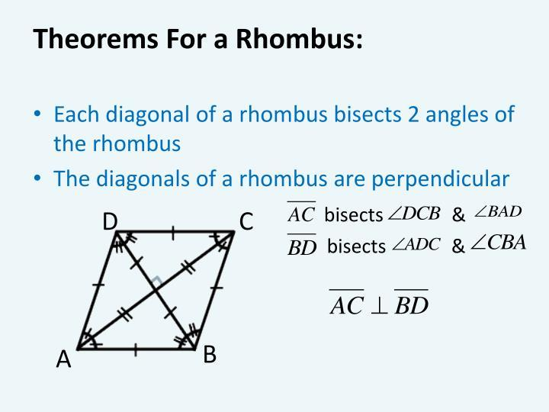
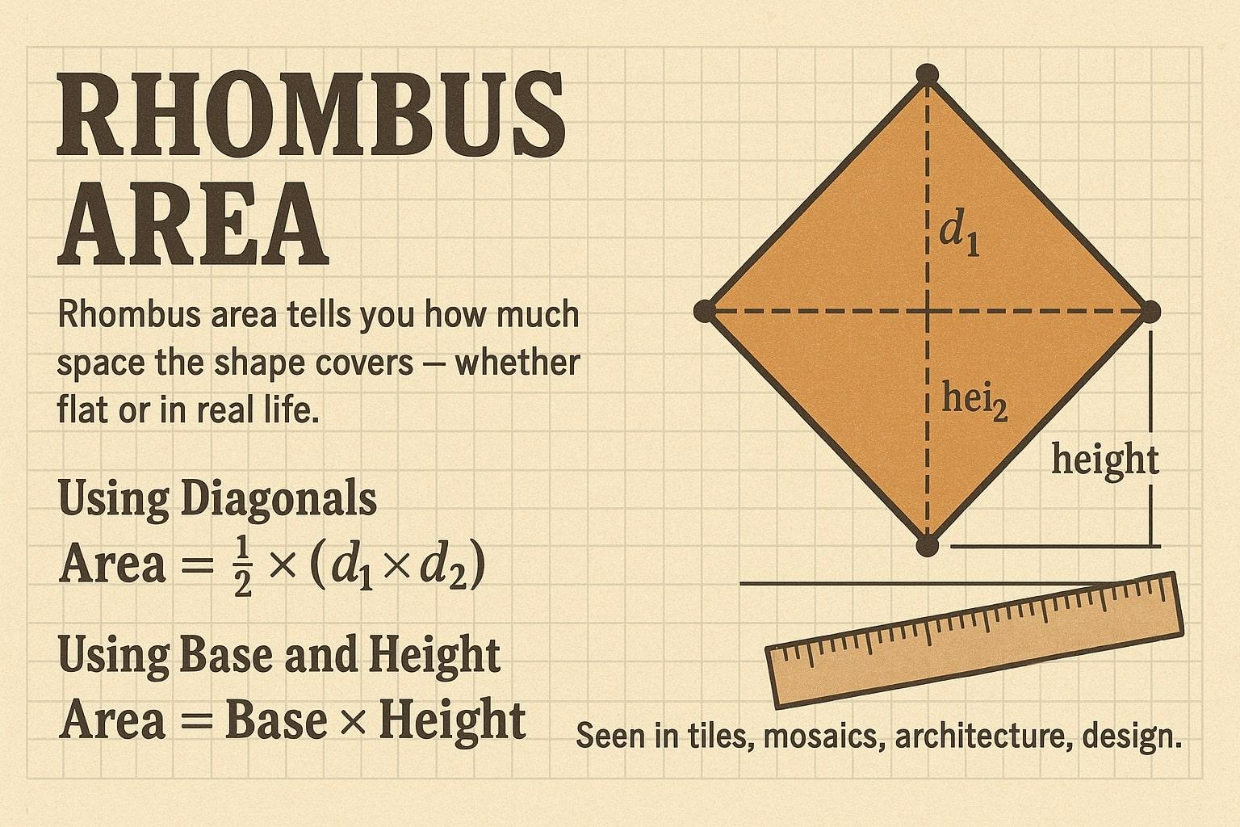

Definition
# Source: AI Source: Provided by: [Data Path: Persons Table -> ID Column: 1, Name_En Column: Motasem Essam] -> From: [ChatGPT] on [7/25/2026]
A rhombus is a quadrilateral with four congruent sides.
For rhombus $ABCD$:
$$\boxed{AB=BC=CD=DA}$$
A rhombus is also a special type of parallelogram, so its opposite sides are parallel:
$$\boxed{AB∥CD} \\ \boxed{BC∥AD}$$

Purpose
# Source: AI Source: Provided by: [Data Path: Persons Table -> ID Column: 1, Name_En Column: Motasem Essam] -> From: [ChatGPT] on [7/25/2026]
A rhombus is used to:
- Study quadrilaterals with four equal sides.
- Analyze relationships between sides and angles.
- Study perpendicular and angle-bisecting diagonals.
- Calculate perimeter and area.
- Understand special properties of parallelograms.
- Model geometric patterns and structures.

Fundamental Elements
# Source: AI Source: Provided by: [Data Path: Persons Table -> ID Column: 1, Name_En Column: Motasem Essam] -> From: [ChatGPT] on [7/25/2026]
Consider rhombus $ABCD$.
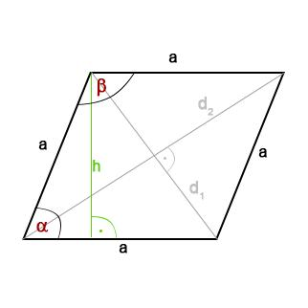
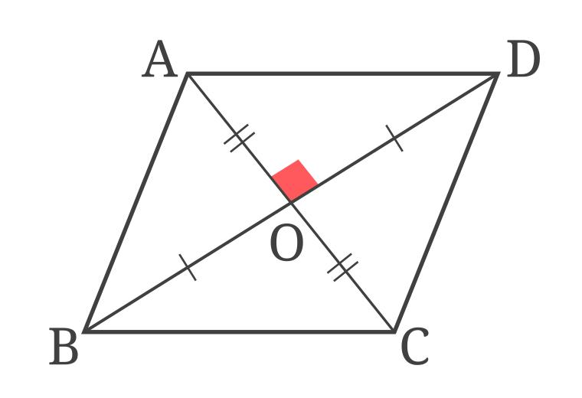
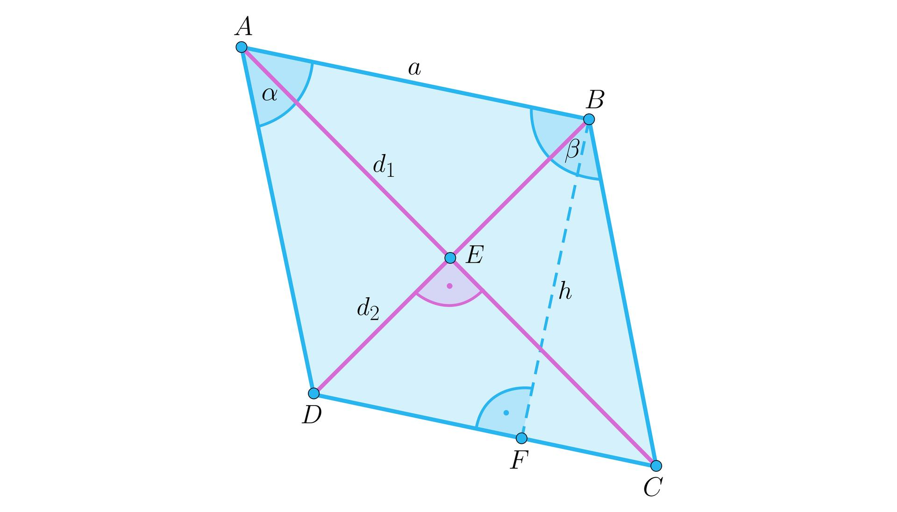
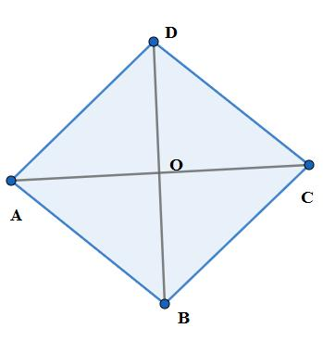
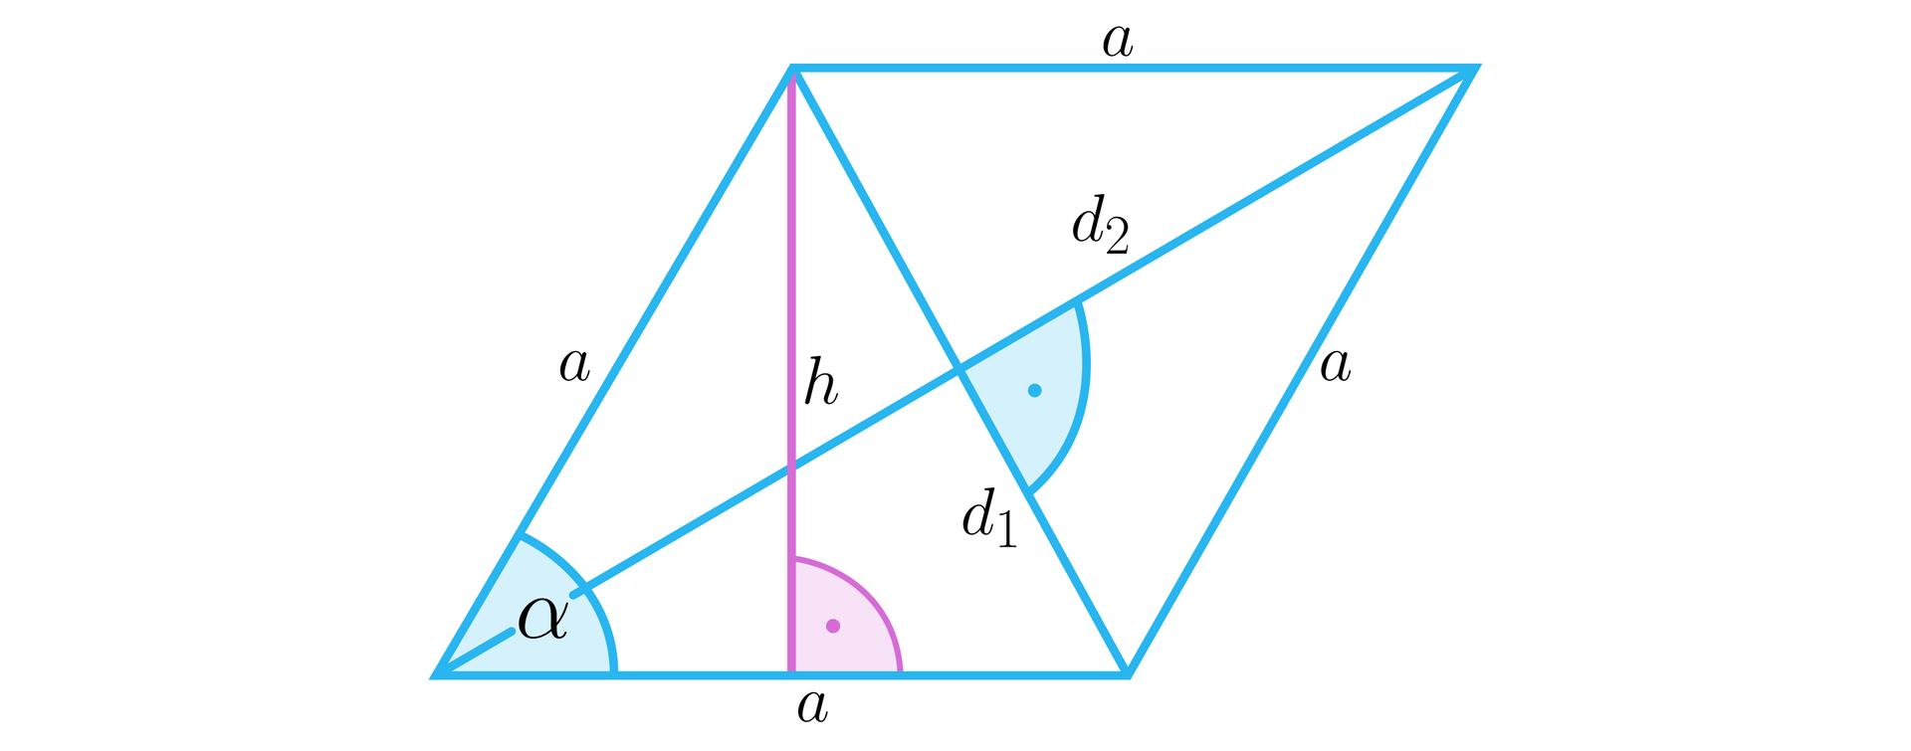

1. Sides
# Source: AI Source: Provided by: [Data Path: Persons Table -> ID Column: 1, Name_En Column: Motasem Essam] -> From: [ChatGPT] on [7/25/2026]
The four sides are:
$$\overset{‾}{AB}, \overset{‾}{BC}, \overset{‾}{CD}, \overset{‾}{DA}$$
All four are congruent:
$$\boxed{AB=BC=CD=DA}$$

2. Vertices
# Source: AI Source: Provided by: [Data Path: Persons Table -> ID Column: 1, Name_En Column: Motasem Essam] -> From: [ChatGPT] on [7/25/2026]
The four vertices are:
$$A, B, C, D$$

3. Interior Angles
# Source: AI Source: Provided by: [Data Path: Persons Table -> ID Column: 1, Name_En Column: Motasem Essam] -> From: [ChatGPT] on [7/25/2026]
The four interior angles are:
$$∠A, ∠B, ∠C, ∠D$$
Opposite angles are congruent:
$$\boxed{∠A=∠C} \\ \boxed{∠B=∠D}$$

4. Diagonals
# Source: AI Source: Provided by: [Data Path: Persons Table -> ID Column: 1, Name_En Column: Motasem Essam] -> From: [ChatGPT] on [7/25/2026]
The diagonals are:
$$\overset{‾}{AC}$$
and:
$$\overset{‾}{BD}$$

5. Base and Height
# Source: AI Source: Provided by: [Data Path: Persons Table -> ID Column: 1, Name_En Column: Motasem Essam] -> From: [ChatGPT] on [7/25/2026]
Any side may be chosen as the base.
The height is the perpendicular distance between the pair of parallel sides.
$$\boxed{h⊥b}$$
The height is generally not equal to the side length.

Fundamental Properties
# Source: AI Source: Provided by: [Data Path: Persons Table -> ID Column: 1, Name_En Column: Motasem Essam] -> From: [ChatGPT] on [7/25/2026]
A rhombus has several important properties.
Property 1: All Four Sides Are Congruent
$$\boxed{AB=BC=CD=DA}$$
Property 2: Opposite Sides Are Parallel
Because a rhombus is a parallelogram:
$$\boxed{AB∥CD} \\ \boxed{BC∥AD}$$
Property 3: Opposite Angles Are Congruent
$$\boxed{∠A=∠C} \\ \boxed{∠B=∠D}$$
Property 4: Consecutive Angles Are Supplementary
$$\boxed{∠A+∠B={180}^{∘}}$$
Property 5: Diagonals Bisect Each Other
If the diagonals intersect at $O$:
$$\boxed{AO=OC}$$
and:
$$\boxed{BO=OD}$$
Property 6: Diagonals Are Perpendicular
The diagonals of a rhombus intersect at right angles:
$$\boxed{AC⊥BD}$$
Property 7: Diagonals Bisect Opposite Angles
Each diagonal bisects a pair of opposite angles.
For example, diagonal $AC$bisects $∠A$and $∠C$:
$$\boxed{∠BAC=∠CAD}$$
and:
$$\boxed{∠BCA=∠ACD}$$

Diagonals
# Source: AI Source: Provided by: [Data Path: Persons Table -> ID Column: 1, Name_En Column: Motasem Essam] -> From: [ChatGPT] on [7/25/2026]
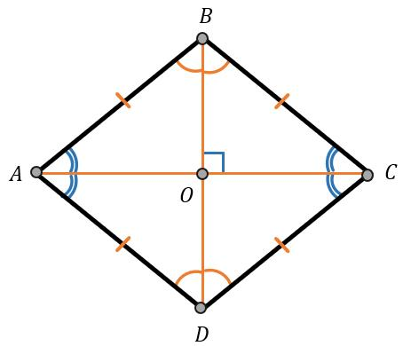
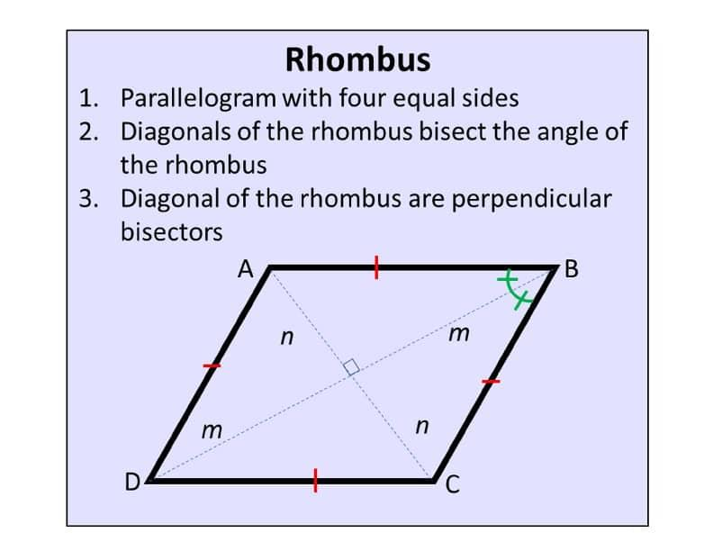
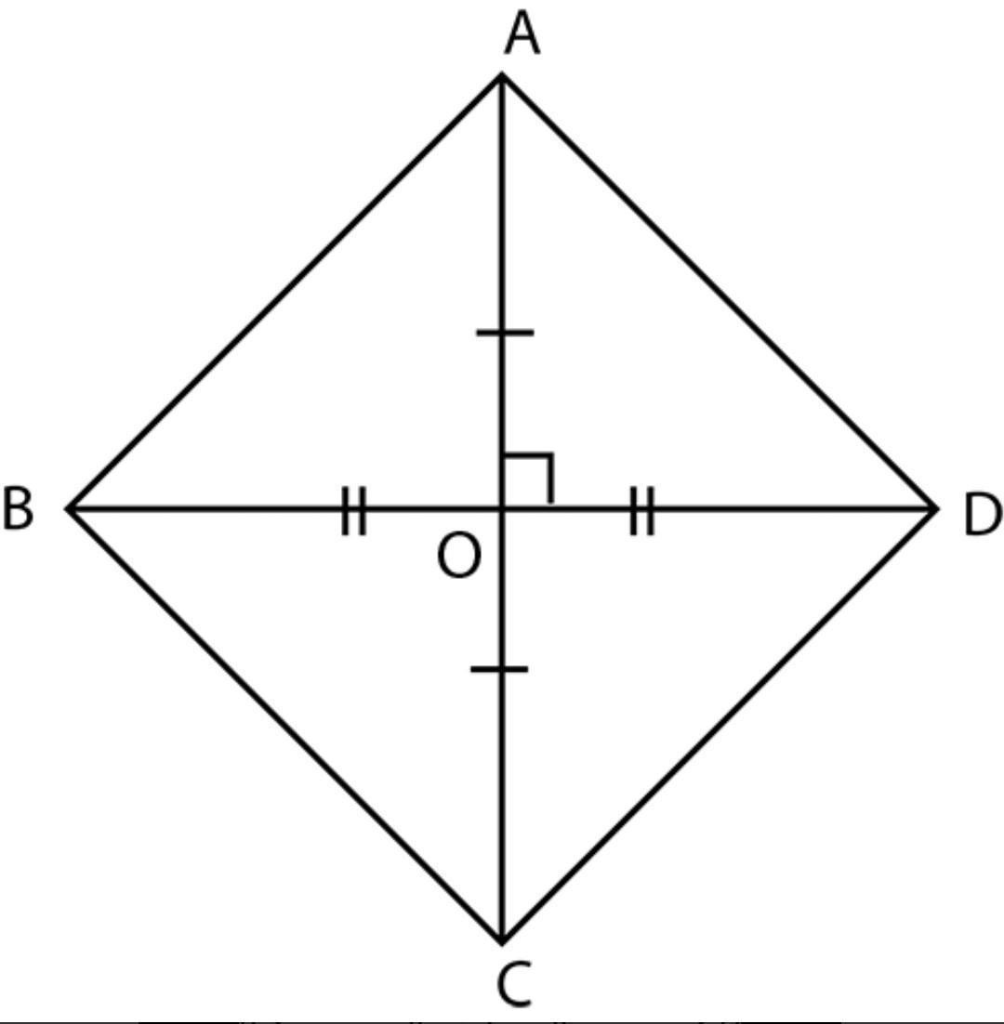
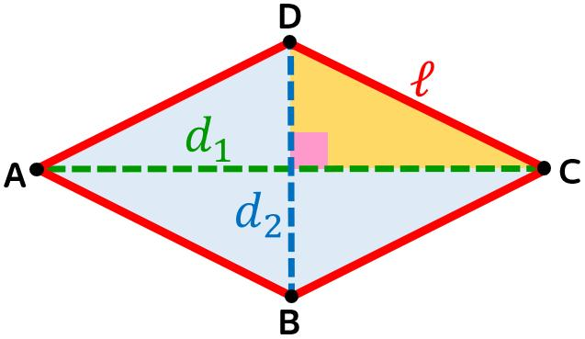
The diagonals are one of the most important features of a rhombus.
They are:
- Perpendicular
- Bisectors of each other
- Angle bisectors
If $O$is the intersection:
$$\boxed{AO=OC} \\ \boxed{BO=OD}$$
and:
$$\boxed{AC⊥BD}$$
Therefore, the four smaller triangles formed by the diagonals are right triangles.

Perimeter
# Source: AI Source: Provided by: [Data Path: Persons Table -> ID Column: 1, Name_En Column: Motasem Essam] -> From: [ChatGPT] on [7/25/2026]
Since all four sides have the same length $s$:
$$\boxed{P=4s}$$
Example
If:
$$s=9\text{ cm}$$
then:
$$P=4\left(9\right) \\ \boxed{P=36\text{ cm}}$$

Area Using Base and Height
# Source: AI Source: Provided by: [Data Path: Persons Table -> ID Column: 1, Name_En Column: Motasem Essam] -> From: [ChatGPT] on [7/25/2026]
The area of a rhombus is:
$$\boxed{A=bh}$$
where:
- $b$= base
- $h$= perpendicular height
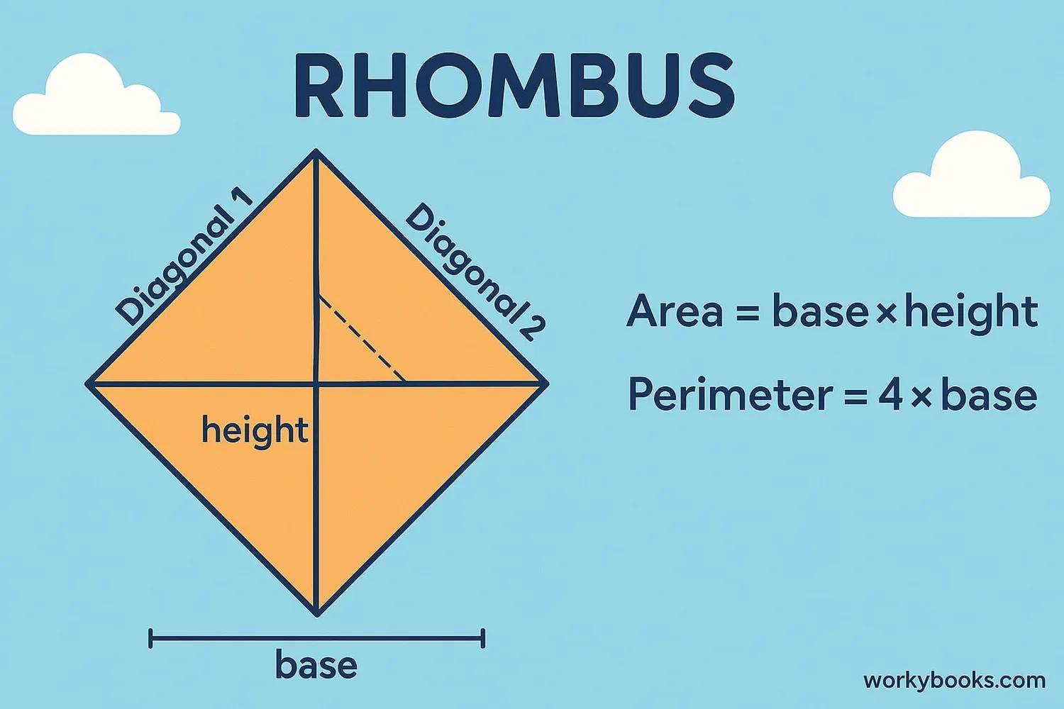
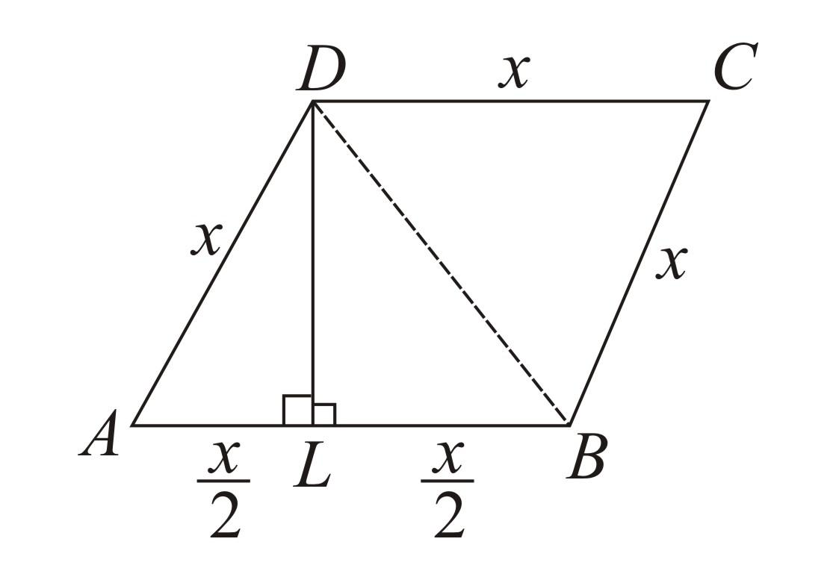
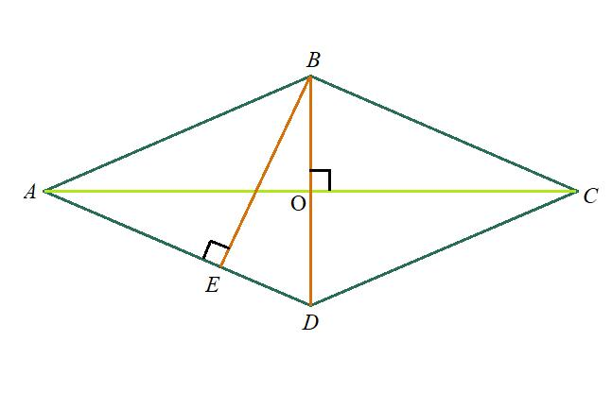
Example
If:
$$b=12\text{ cm}$$
and:
$$h=7\text{ cm}$$
then:
$$A=12\left(7\right) \\ \boxed{A=84{\text{ cm}}^{2}}$$

Area Using Diagonals
# Source: AI Source: Provided by: [Data Path: Persons Table -> ID Column: 1, Name_En Column: Motasem Essam] -> From: [ChatGPT] on [7/25/2026]
If the diagonals have lengths $d_{1}$and $d_{2}$, the area is:
$$\boxed{A=\frac{1}{2}d_{1}d_{2}}$$
Example
Suppose:
$$d_{1}=10\text{ cm}$$
and:
$$d_{2}=8\text{ cm}$$
Then:
$$A=\frac{1}{2}\left(10\right)\left(8\right) \\ \boxed{A=40{\text{ cm}}^{2}}$$

Area Using Two Sides and an Included Angle
# Source: AI Source: Provided by: [Data Path: Persons Table -> ID Column: 1, Name_En Column: Motasem Essam] -> From: [ChatGPT] on [7/25/2026]
Since all sides have length $s$, if the included angle is $θ$:
$$\boxed{A=s^{2}\sin{θ}}$$
Example
A rhombus has side length:
$$s=6\text{ cm}$$
and included angle:
$$θ={30}^{∘}$$
Then:
$$A=6^{2}\sin{{30}^{∘}} \\ A=36\left(\frac{1}{2}\right) \\ \boxed{A=18{\text{ cm}}^{2}}$$

Relationship Between the Diagonals and Side
# Source: AI Source: Provided by: [Data Path: Persons Table -> ID Column: 1, Name_En Column: Motasem Essam] -> From: [ChatGPT] on [7/25/2026]
Because the diagonals are perpendicular and bisect each other, half of each diagonal and a side form a right triangle.
Therefore:
$${\left(\frac{d_{1}}{2}\right)}^{2}+{\left(\frac{d_{2}}{2}\right)}^{2}=s^{2}$$
Equivalently:
$$\boxed{d_{1}^{2}+d_{2}^{2}=4s^{2}}$$
Example
Suppose:
$$d_{1}=6\text{ cm}$$
and:
$$d_{2}=8\text{ cm}$$
Then:
$$s=\sqrt{{\left(\frac{6}{2}\right)}^{2}+{\left(\frac{8}{2}\right)}^{2}} \\ s=\sqrt{3^{2}+4^{2}} \\ s=\sqrt{25} \\ \boxed{s=5\text{ cm}}$$

Angles
# Source: AI Source: Provided by: [Data Path: Persons Table -> ID Column: 1, Name_En Column: Motasem Essam] -> From: [ChatGPT] on [7/25/2026]
Because a rhombus is a parallelogram:
- Opposite angles are equal.
- Consecutive angles are supplementary.
Example
If:
$$∠A={70}^{∘}$$
then:
$$∠C={70}^{∘}$$
and:
$$∠B=∠D={110}^{∘}$$
because:
$${180}^{∘}-{70}^{∘}={110}^{∘}$$

Symmetry
# Source: AI Source: Provided by: [Data Path: Persons Table -> ID Column: 1, Name_En Column: Motasem Essam] -> From: [ChatGPT] on [7/25/2026]
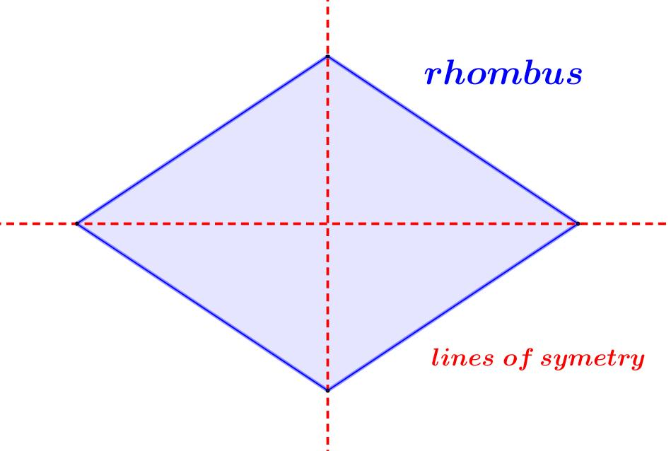
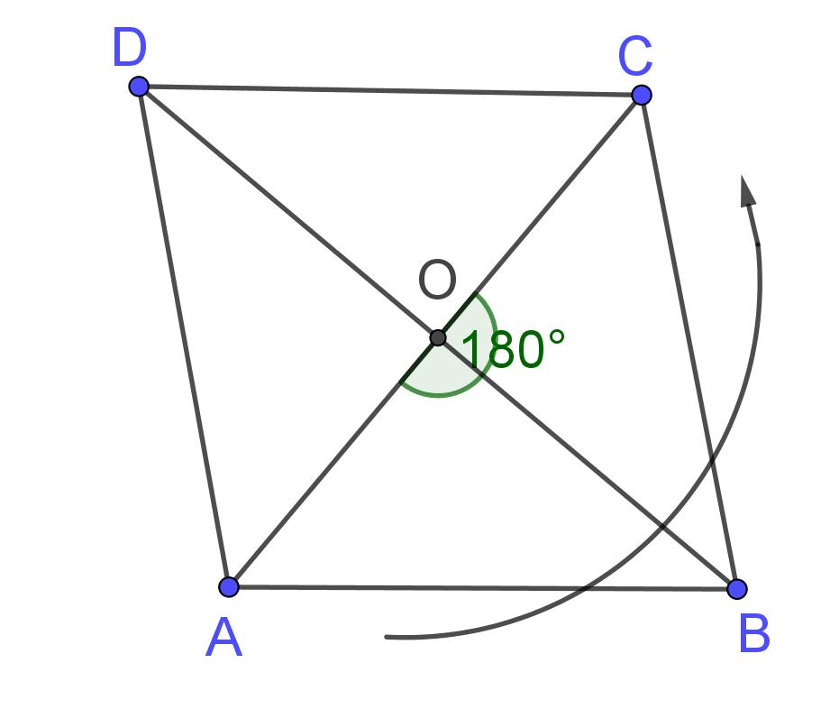
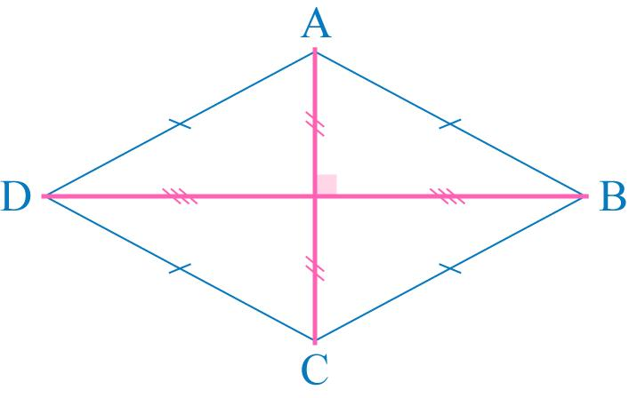
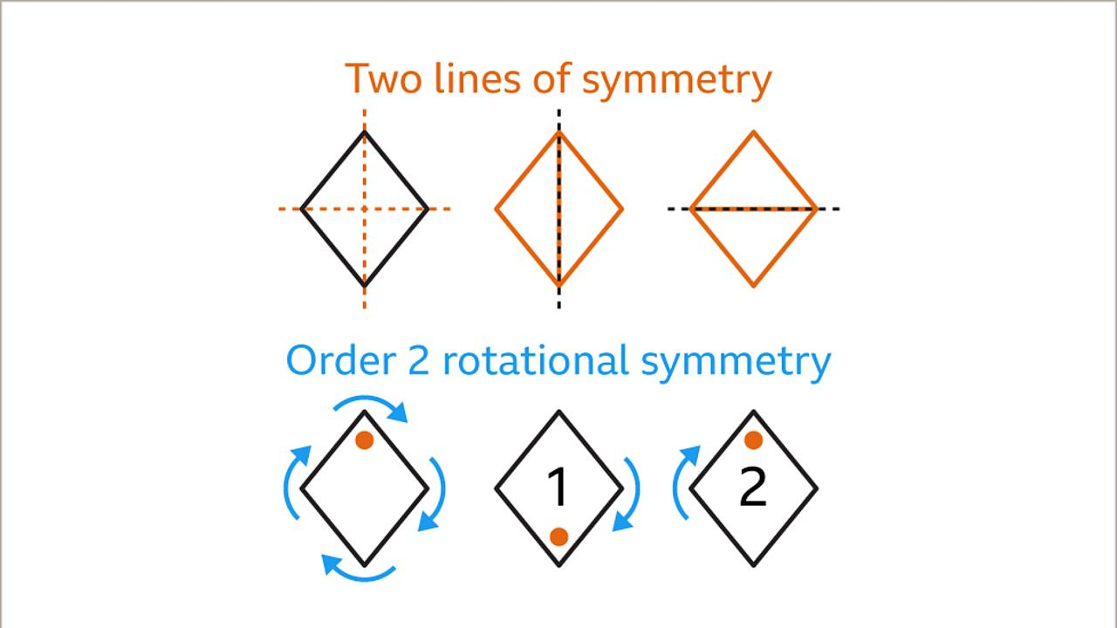
A general rhombus has:
$$\boxed{2}$$
lines of symmetry, which are its diagonals.
It also has rotational symmetry of order:
$$\boxed{2}$$
The smallest non-zero rotation that maps it onto itself is:
$$\boxed{{180}^{∘}}$$
Special Case: Square
A square is a special rhombus.
Therefore, a square has 4 lines of symmetry and rotational symmetry of order 4.

Rhombus as a Parallelogram
# Source: AI Source: Provided by: [Data Path: Persons Table -> ID Column: 1, Name_En Column: Motasem Essam] -> From: [ChatGPT] on [7/25/2026]
Every rhombus is a parallelogram because its opposite sides are parallel.
$$\boxed{\text{Rhombus}⊂\text{Parallelogram}}$$
Therefore, a rhombus inherits the properties of a parallelogram:
- Opposite sides are parallel.
- Opposite sides are congruent.
- Opposite angles are congruent.
- Consecutive angles are supplementary.
- Diagonals bisect each other.
The rhombus adds:
- Four equal sides.
- Perpendicular diagonals.
- Diagonals that bisect the angles.

Rhombus and Rectangle
# Source: AI Source: Provided by: [Data Path: Persons Table -> ID Column: 1, Name_En Column: Motasem Essam] -> From: [ChatGPT] on [7/25/2026]
Both are special types of parallelograms.
A rectangle has:
$$\boxed{4\text{ right angles}}$$
A rhombus has:
$$\boxed{4\text{ equal sides}}$$
A quadrilateral that has both properties is a:
$$\boxed{\text{Square}}$$

Rhombus and Square
# Source: AI Source: Provided by: [Data Path: Persons Table -> ID Column: 1, Name_En Column: Motasem Essam] -> From: [ChatGPT] on [7/25/2026]
A square is a special type of rhombus.
Both have:
- Four equal sides.
- Opposite sides parallel.
- Opposite angles congruent.
- Perpendicular diagonals.
- Diagonals that bisect each other.
- Diagonals that bisect the angles.
The additional property of a square is:
$$\boxed{\text{Four right angles}}$$
Therefore:
$$\boxed{\text{Every square is a rhombus}}$$
but:
$$\boxed{\text{Not every rhombus is a square}}$$

Classification Relationship
# Source: AI Source: Provided by: [Data Path: Persons Table -> ID Column: 1, Name_En Column: Motasem Essam] -> From: [ChatGPT] on [7/25/2026]
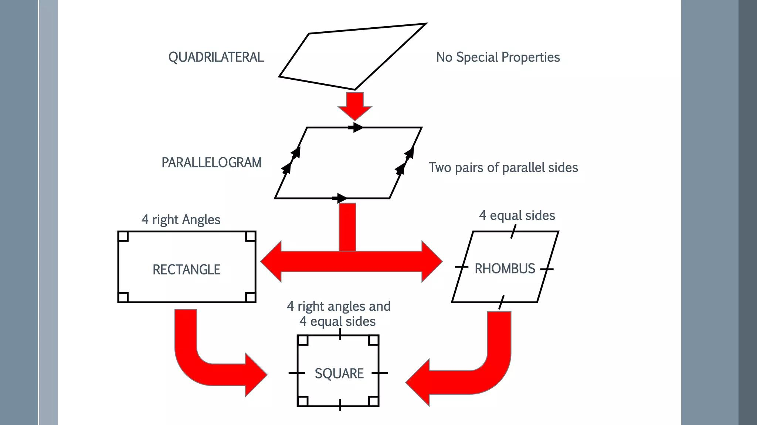
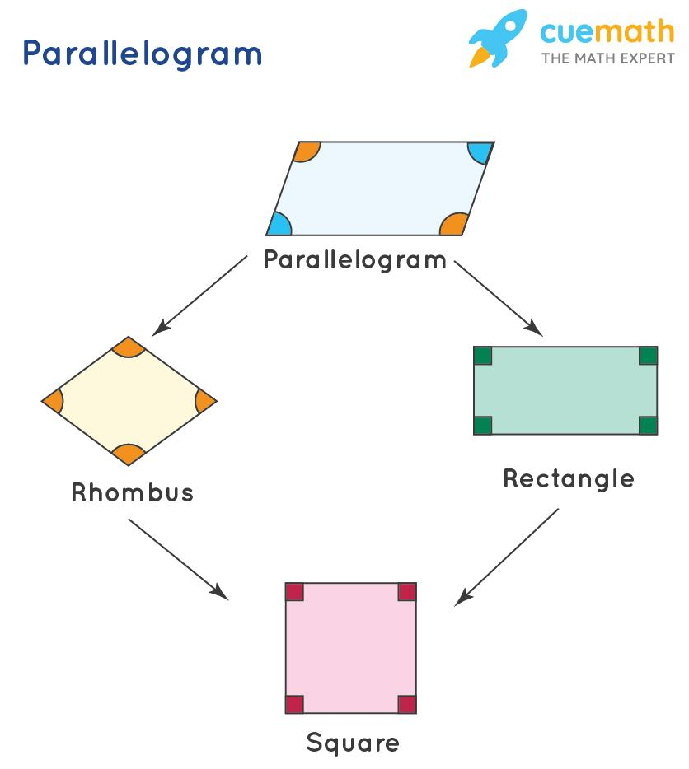
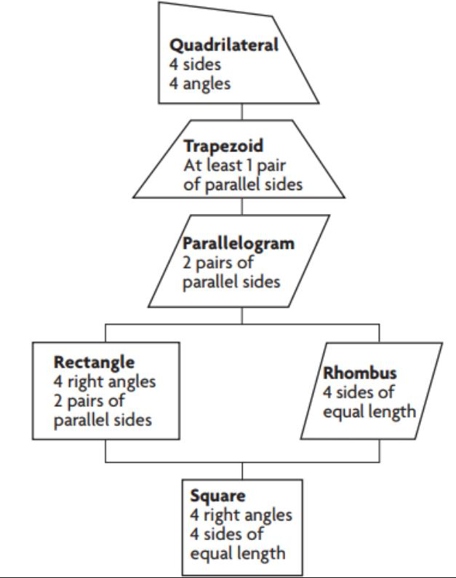
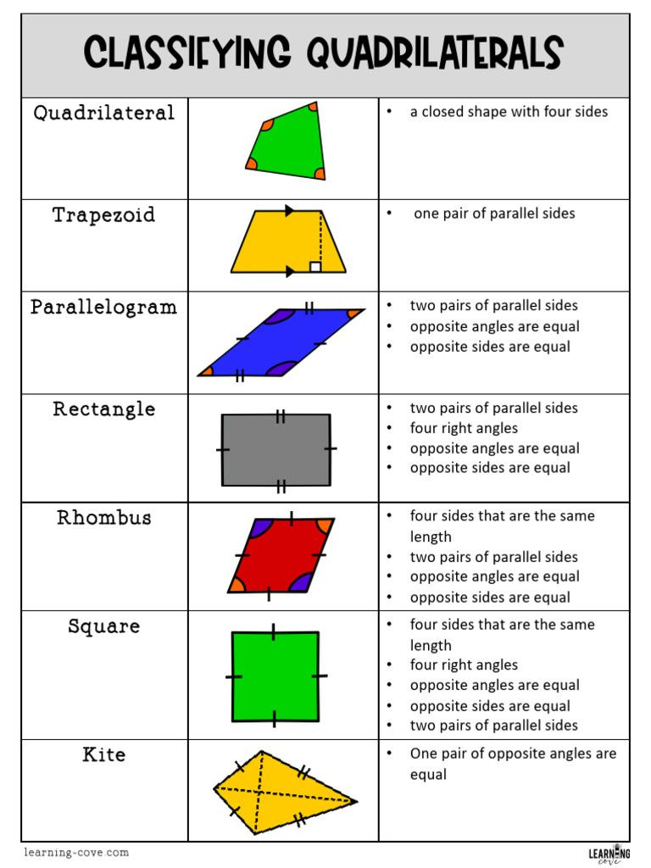
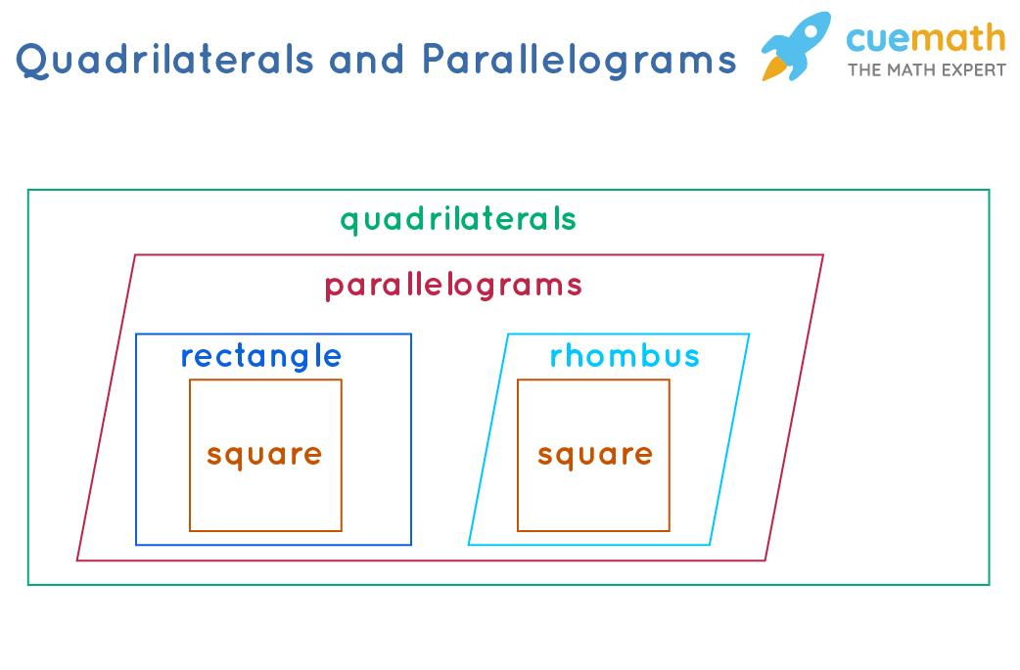
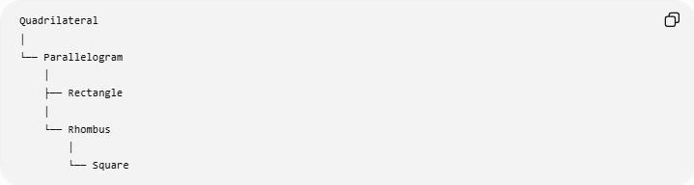
Quadrilateral
│
└── Parallelogram
│
├── Rectangle
│
└── Rhombus
│
└── Square
The square belongs to both the rectangle and rhombus categories.

Ways to Identify a Rhombus
# Source: AI Source: Provided by: [Data Path: Persons Table -> ID Column: 1, Name_En Column: Motasem Essam] -> From: [ChatGPT] on [7/25/2026]
A parallelogram is a rhombus if it satisfies the defining condition:
$$\boxed{\text{All four sides are congruent}}$$
There are also useful tests for proving a parallelogram is a rhombus:
1. All four sides are congruent
$$AB=BC=CD=DA$$
2. The diagonals are perpendicular
For a parallelogram, if:
$$AC⊥BD$$
then it is a rhombus.
3. A diagonal bisects a pair of opposite angles
If a diagonal of a parallelogram bisects an opposite pair of angles, the parallelogram is a rhombus.

Examples

Example 1: Find the Perimeter
# Source: AI Source: Provided by: [Data Path: Persons Table -> ID Column: 1, Name_En Column: Motasem Essam] -> From: [ChatGPT] on [7/25/2026]
A rhombus has side length:
$$s=11\text{ cm}$$
Then:
$$P=4s \\ P=4\left(11\right) \\ \boxed{P=44\text{ cm}}$$

Example 2: Find the Area Using Diagonals
# Source: AI Source: Provided by: [Data Path: Persons Table -> ID Column: 1, Name_En Column: Motasem Essam] -> From: [ChatGPT] on [7/25/2026]
The diagonals measure:
$$d_{1}=12\text{ cm}$$
and:
$$d_{2}=16\text{ cm}$$
Then:
$$A=\frac{1}{2}d_{1}d_{2} \\ A=\frac{1}{2}\left(12\right)\left(16\right) \\ \boxed{A=96{\text{ cm}}^{2}}$$

Example 3: Find a Missing Diagonal Segment
# Source: AI Source: Provided by: [Data Path: Persons Table -> ID Column: 1, Name_En Column: Motasem Essam] -> From: [ChatGPT] on [7/25/2026]
The diagonals intersect at $O$.
Suppose:
$$AO=7\text{ cm}$$
Because the diagonals bisect each other:
$$AO=OC$$
Therefore:
$$\boxed{OC=7\text{ cm}}$$
and:
$$AC=7+7 \\ \boxed{AC=14\text{ cm}}$$

Example 4: Find the Missing Angle
# Source: AI Source: Provided by: [Data Path: Persons Table -> ID Column: 1, Name_En Column: Motasem Essam] -> From: [ChatGPT] on [7/25/2026]
Suppose:
$$∠A={65}^{∘}$$
Since opposite angles are congruent:
$$\boxed{∠C={65}^{∘}}$$
Since consecutive angles are supplementary:
$$∠B={180}^{∘}-{65}^{∘} \\ \boxed{∠B={115}^{∘}}$$
Therefore:
$$\boxed{∠D={115}^{∘}}$$

Example 5: Find the Side from the Diagonals
# Source: AI Source: Provided by: [Data Path: Persons Table -> ID Column: 1, Name_En Column: Motasem Essam] -> From: [ChatGPT] on [7/25/2026]
A rhombus has diagonals:
$$d_{1}=10\text{ cm}$$
and:
$$d_{2}=24\text{ cm}$$
Using:
$$s=\sqrt{{\left(\frac{d_{1}}{2}\right)}^{2}+{\left(\frac{d_{2}}{2}\right)}^{2}}$$
we get:
$$s=\sqrt{5^{2}+{12}^{2}} \\ s=\sqrt{25+144} \\ s=\sqrt{169} \\ \boxed{s=13\text{ cm}}$$

Real-World Applications
# Source: AI Source: Provided by: [Data Path: Persons Table -> ID Column: 1, Name_En Column: Motasem Essam] -> From: [ChatGPT] on [7/25/2026]

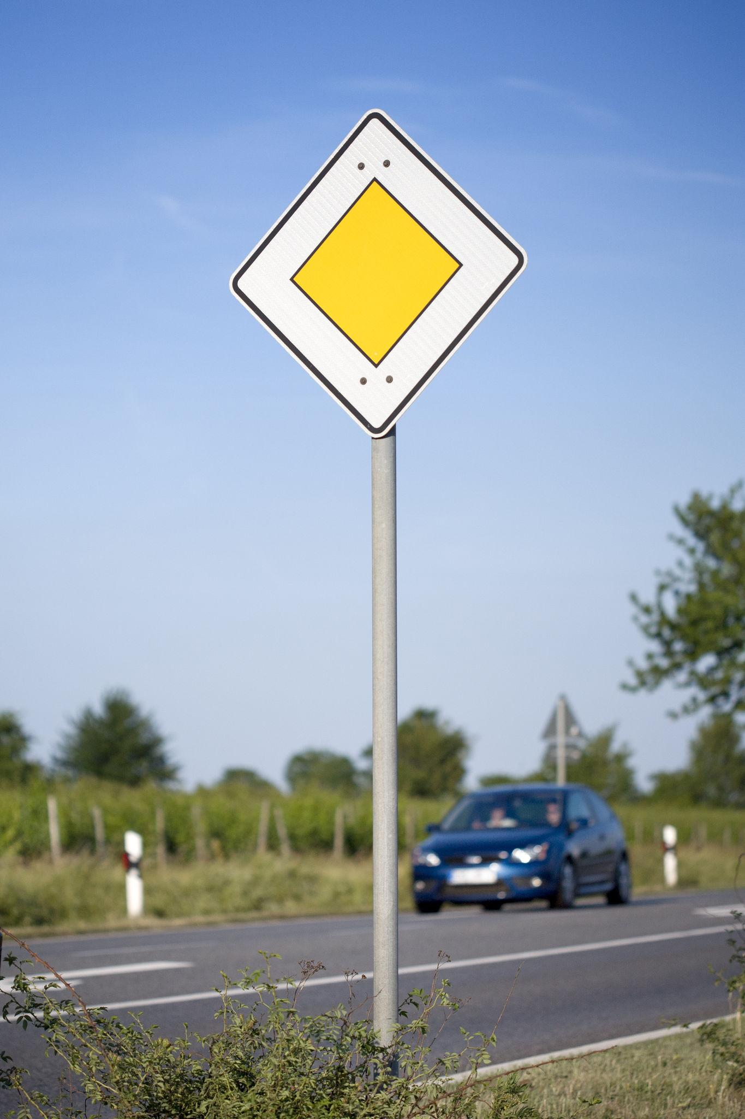
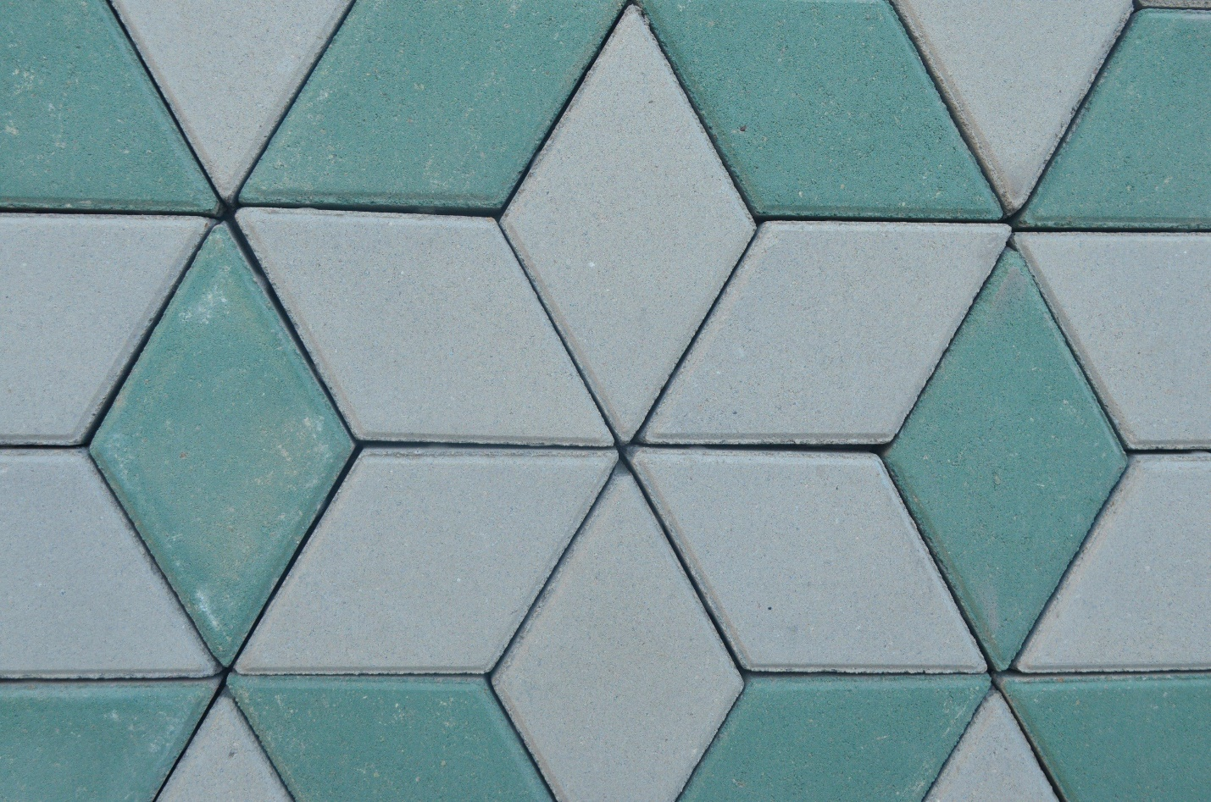
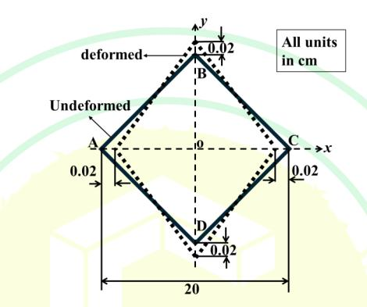

Rhombus-shaped forms appear in:
- Diamond-shaped road signs.
- Floor and wall tiles.
- Decorative geometric patterns.
- Architecture.
- Engineering structures.
- Textile and fabric patterns.
- Graphic and logo design.
- Mathematical tessellations.

Advantages
# Source: AI Source: Provided by: [Data Path: Persons Table -> ID Column: 1, Name_En Column: Motasem Essam] -> From: [ChatGPT] on [7/25/2026]
- All four sides have the same length.
- Diagonal properties make many calculations convenient.
- Area can be calculated using either base-height or diagonals.
- Provides a useful special case of a parallelogram.
- Has strong symmetry properties.
- Important for understanding squares and quadrilateral classification.

Limitations
# Source: AI Source: Provided by: [Data Path: Persons Table -> ID Column: 1, Name_En Column: Motasem Essam] -> From: [ChatGPT] on [7/25/2026]
- A general rhombus does not necessarily have right angles.
- Its diagonals are not necessarily congruent.
- The side length should not be confused with the perpendicular height.
- A diagram alone cannot prove that all four sides are equal.
- A rhombus is not necessarily a square.

Comparison with Related Quadrilaterals
# Source: AI Source: Provided by: [Data Path: Persons Table -> ID Column: 1, Name_En Column: Motasem Essam] -> From: [ChatGPT] on [7/25/2026]
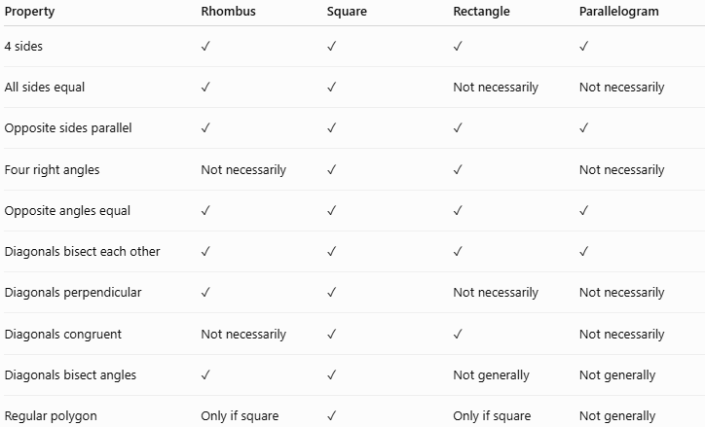
Property | Rhombus | Square | Rectangle | Parallelogram
4 sides | ✓ | ✓ | ✓ | ✓
All sides equal | ✓ | ✓ | Not necessarily | Not necessarily
Opposite sides parallel | ✓ | ✓ | ✓ | ✓
Four right angles | Not necessarily | ✓ | ✓ | Not necessarily
Opposite angles equal | ✓ | ✓ | ✓ | ✓
Diagonals bisect each other | ✓ | ✓ | ✓ | ✓
Diagonals perpendicular | ✓ | ✓ | Not necessarily | Not necessarily
Diagonals congruent | Not necessarily | ✓ | ✓ | Not necessarily
Diagonals bisect angles | ✓ | ✓ | Not generally | Not generally
Regular polygon | Only if square | ✓ | Only if square | Not generally

Key Points
# Source: AI Source: Provided by: [Data Path: Persons Table -> ID Column: 1, Name_En Column: Motasem Essam] -> From: [ChatGPT] on [7/25/2026]
- A rhombus is a quadrilateral with four congruent sides.
- A rhombus is a special type of parallelogram.
- Opposite sides are parallel:
$$\boxed{AB∥CD, BC∥AD}$$
- Opposite angles are congruent:
$$\boxed{∠A=∠C, ∠B=∠D}$$
- Consecutive angles are supplementary.
- Diagonals bisect each other:
$$\boxed{AO=OC, BO=OD}$$
- Diagonals are perpendicular:
$$\boxed{AC⊥BD}$$
- Diagonals bisect opposite angles.
- Perimeter:
$$\boxed{P=4s}$$
- Area using base and height:
$$\boxed{A=bh}$$
- Area using diagonals:
$$\boxed{A=\frac{1}{2}d_{1}d_{2}}$$
- Every square is a rhombus.
- Not every rhombus is a square.

Conclusion
# Source: AI Source: Provided by: [Data Path: Persons Table -> ID Column: 1, Name_En Column: Motasem Essam] -> From: [ChatGPT] on [7/25/2026]
A rhombus is a four-sided polygon with four congruent sides and is a special type of parallelogram. Its most distinctive properties are that its diagonals are perpendicular, bisect each other, and bisect the opposite angles. The rhombus is especially important in quadrilateral classification because a square is a special rhombus that additionally has four right angles.
Would you like a short rhombus study sheet or a few practice problems?

